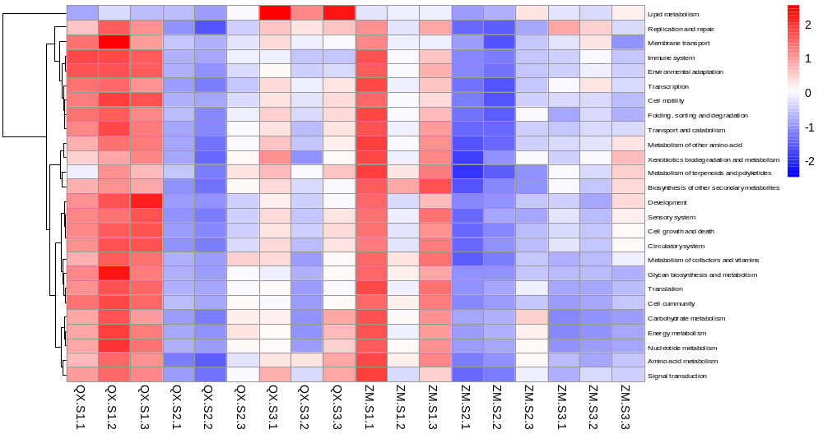
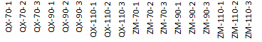
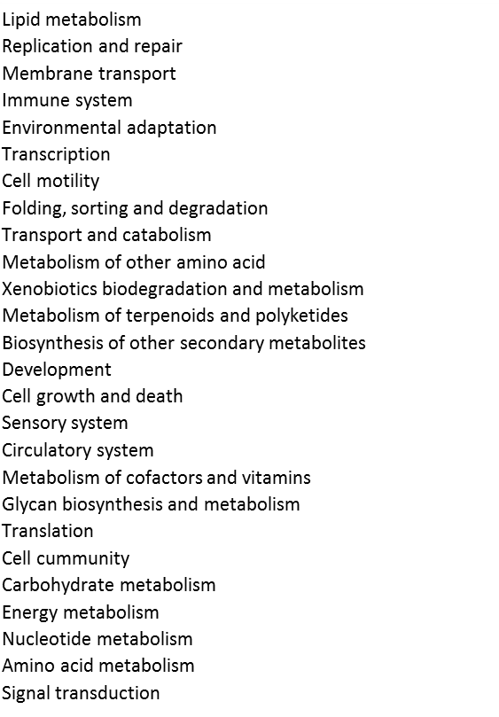

Supplementary Fig. 4 Clustering analysis (heatmap) of annotations for metabolic pathways. Red indicates high gene expression activitity; white indicates medium activity and blue indicates low activity. KEGG categories were labled in the right of each heatmap line.

